There are a few reasons why the [WiFi icon](http://windowsreport.com/laptop-not-showing-wifi-icon/) on the main menu of the desktop has an **exclamation mark**. One of the most common issues for this problem is low network connectivity. This isn’t the only issue that can arise. There are other possible reasons triggering the exclamation mark. Perform the following fixes to troubleshoot the issue.

### Limited Network Connectivity Troubleshooting

If this is the first time connecting to a particular network, the issue could be that the password was entered wrong. Always double check the password before troubleshooting any [connection issues](http://windowsreport.com/wifi-disconnects-pc/). If you’ve already been connected to the network with no issues, then perform the following steps:

1. Check all networking wires to ensure that each connection is secure and properly connected.
2. Unplug the Modem for 30 seconds.
3. Restart the modem and check the connection.

**Note: If the modem is hard reset ensure that all of the network passwords are known.**

1. Reset your modem by using the reset button at the back of the modem (typically a pinhole button) if the restart failed.                                                                                                  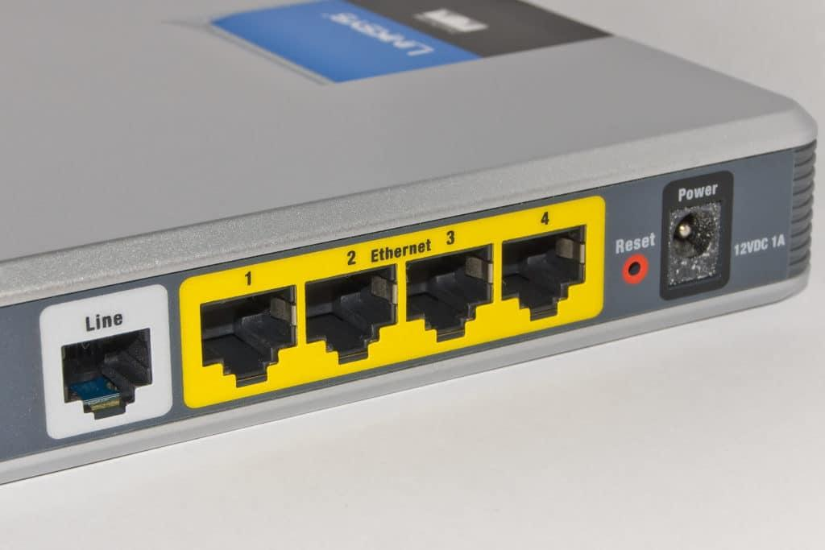
2. Restart the computer.
3. Call your Internet Service Provider for individual modem troubleshooting if any of your modem lights remain red.

### Delete the Network Profile

If the issue persists delete the network profile and try re-installing it. Follow these procedures to perform this task:

1. Open the **Command Prompt** as an administrator (**Ctrl+Shift + Enter**).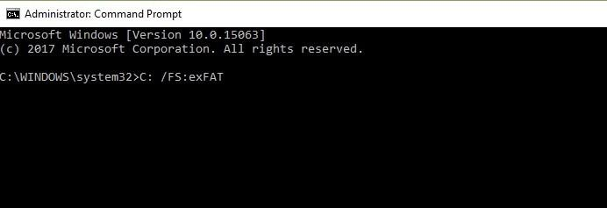
2. Type the following command:

**netsh wlan delete profile name=type-wireless-profile-name**

1. Reinstall the network by opening the**Control Panel .**
2. Open**Network and Internet.**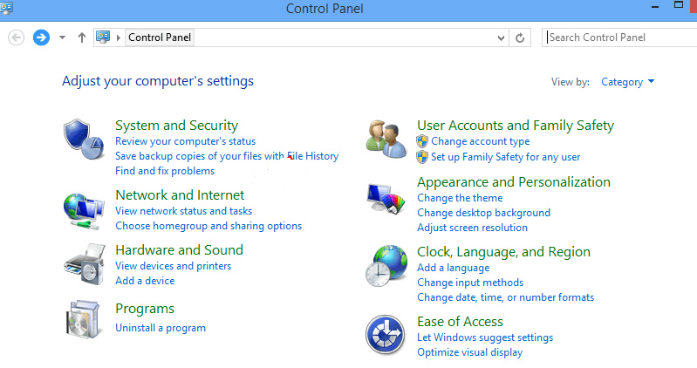
3. Click on **Connect to a Network.**
4. Follow the on-screen prompts.

### Reset Winsock

**Note:** Before resetting Winsock we recommend creating a system restore point.

Winsock is a technical element that allows the computer to connect to a TCP/IP. If this element is corrupt it can interrupt the connection. To reset Winsock complete the following steps:

1. Open the **Command Prompt** as an administrator (**Ctrl+Shift + Enter**).
2. Type the following:

**netsh winsock reset**

1. Press **Enter.**
2. Restart the Modem.

### Run an IP Config

Every time a system is connected to the internet [a new IP address](http://windowsreport.com/ip-address-windows-10/) is generated. Sometimes renewing your IP address can solve connectivity issues. To do this perform the following steps:

1. Open the **Command Prompt** as an administrator (**Ctrl+Shift + Enter)**.
2. **Release** the previous **IP Address** by typing the following command:

**ipconfig /release**

1. **Renew** the **IP Address** by typing the following command:

**ipconfig /renew**

### Reset TCP/IP

Often the issue of connectivity remains with the internet protocol or TCP/IP. If this is the issue the TCP/IP must be reset. Perform the following steps to reset the TCP/IP:

1. Open the **Command Prompt** as an administrator (**Ctrl+Shift + Enter**).
2. **Reset** the TCP/IP by typing the following command:

**netsh int ip reset resettcpip.txt**

### Troubleshoot Network Connections

Windows has a [built-in troubleshooting guide](http://windowsreport.com/fix-windows-10-creators-update/) for network connections. To run this guide perform the following steps:

1. Open the **Control Panel**.
2. Click on **Network and Internet**.
3. Click on **Troubleshoot Problems**.
4. Follow the onscreen instructions.

### Network Reset Tool

Windows 10 has a built-in network reset tool to aid in troubleshooting connectivity issues. To access this extremely useful tool perform the following tasks:

1. Click on the **Start Menu**.
2. Open the **Settings**.
3. Click on **Network and Internet**.
4. Under the **Status Menu** look for **Network Troubleshooter**.
5. Click on **Network Reset**.

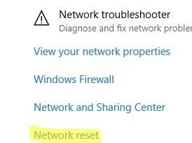

### Reinstall Network Adapter

If the network adapter encountered errors the best solution is to fix it is to uninstall it and let the computer auto-detect it and reinstall it. To perform this fix perform the following tasks:

1. Open the **Control Panel.**
2. Click in the **Search Box** and type **Device Manager.**
3. Click on**Network Adapters.**
4. Right click on the adapter you would like to uninstall and select **Uninstall.**
5. Restart your computer and follow the on-screen commands.

### Fail-Safe

If all else fails there is another solution to the WiFi exclamation point fault. This option is to buy a USB supported [WiFi Network Adapter](http://windowsreport.com/wifi-adapter-not-working-windows-10/). These gadgets aren’t very costly and simply plug into the USB port.